# Python web design 2025/5/1

## Setup for the VS code environment

1. There are two types of command prompt mode in MS Windows.
2. Powershell (The new one).
3. Command Prompt Mode (CMD, old one)

In Windows, please use CMD.

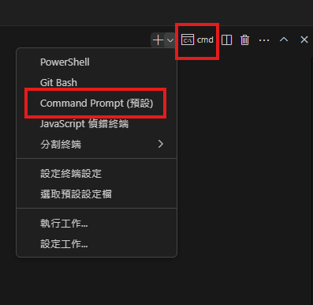

1. Right click on the lesson2 file folder and select “Open the integrated terminal”, the command prompt mode will show in the lower part of the VS code.

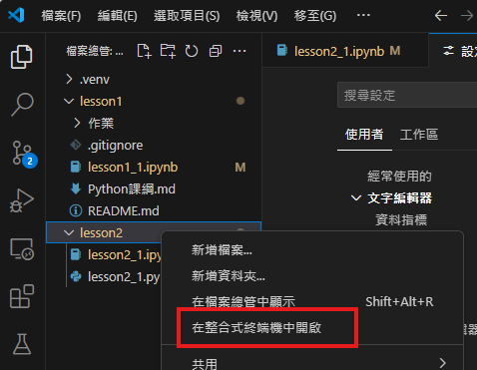

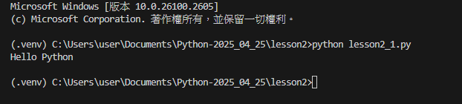

1. There are also two types of shell in Mac OS.
2. Zsh (Apple default shell)
3. Bash (from Linux)

In Mac OS, please use Zsh.

1. Each project file has it’s own .venv file.

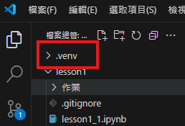

1. If .ipynb file type is used, make sure the VS code top right corner indicates .venv(Python 3.13.2) as below

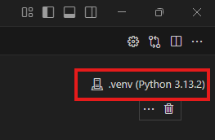

1. If .py file type is used, except the .venv in item 3, please check below.

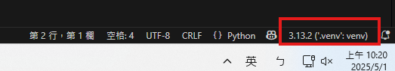

1. Make sure the command prompt mode use the .venv setting as well.



1. If you have PC at home and want to sync the files in the class, click the sync icon as below at the lower left corner of VS code.

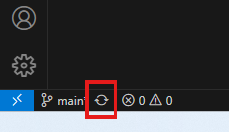

1. If you sill experience the sync issue, try to issue the command to solve the sync issue.

C:> git push --force

## Call function

1. Call with arguments:

The arguments must be entered by order and can’t missing any of the argument.

def menu(wine, entree, dessert):

    print("wine: ",wine,"entree: ", entree, "dessert: ", dessert)

menu('White wine','Steak','Cake')

Note: If the code is modified, make sure to click “Run” at the left side of the box.

Add type hint for function arguments and function:

1. def menu(wine:str, entree:str, dessert:str) -> dict:
2. return {"wine":wine,"entree":entree, "dessert":dessert}

pk:dict = menu("White wine", "Steak","Cake")

pk

{'wine': 'White wine', 'entree': 'Steak', 'dessert': 'Cake'}

Type hint can be used in 3 places:

1. Variable declaration.
2. Function declaration.
3. Function arguments.

2. Call with argument name:

pk:dict = menu(wine = 'White wine', entree = 'Steak', dessert = 'Cake')

pk

{'wine': 'White wine', 'entree': 'Steak', 'dessert': 'Cake'}

pk:dict = menu(wine = 'White wine',  dessert = 'Cake', entree = 'Steak')

pk

{'wine': 'White wine', 'entree': 'Steak', 'dessert': 'Cake'}

Note: Call with argument name, the arguments allow not to fill in the function by order.

3. Call with hybrid of argument and argument name:

This type of call, the argument must be used first then follow the argument name. Please see below.

pk:dict = menu('White wine',  dessert = 'Cake', entree = 'Steak')

pk

{'wine': 'White wine', 'entree': 'Steak', 'dessert': 'Cake'}

Function argument with ‘*’ (eg. *object) means it can be any type of variable and unlimited numbers of variables and values. Please refer to the print() function definitions.

# Special Arguments

*args: Unlimited numbers of arguments.

**kwargs: Unlimited numbers of arguments with name.

def print_all(*arg,**args):

    print('This is a tuple:',arg)

    print('This is a dict:',args)

print_all(1,2,3,4,5,6,'A','B','C',one = 1, two = 2, three =3, four = 4)

This is a tuple: (1, 2, 3, 4, 5, 6, 'A', 'B', 'C')

This is a dict: {'one': 1, 'two': 2, 'three': 3, 'four': 4}

# Class

Note: Search Python內建函式庫

Use type() function to check the variable type.

Perplexity AI search.